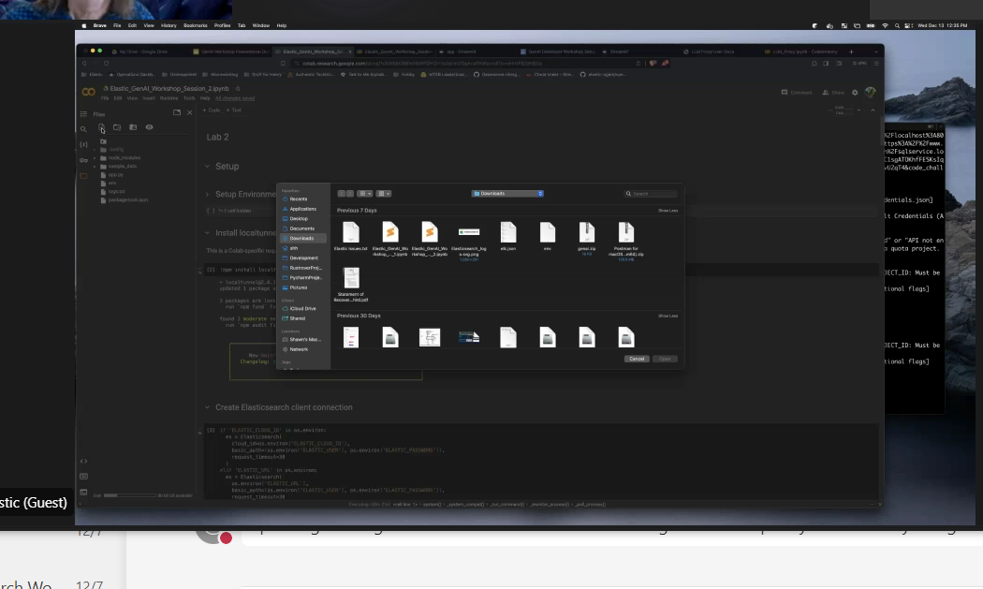

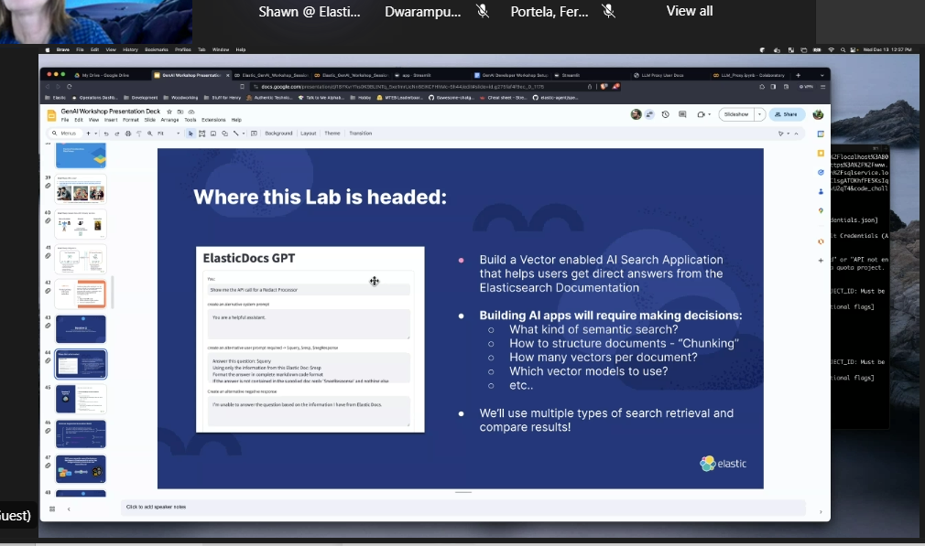



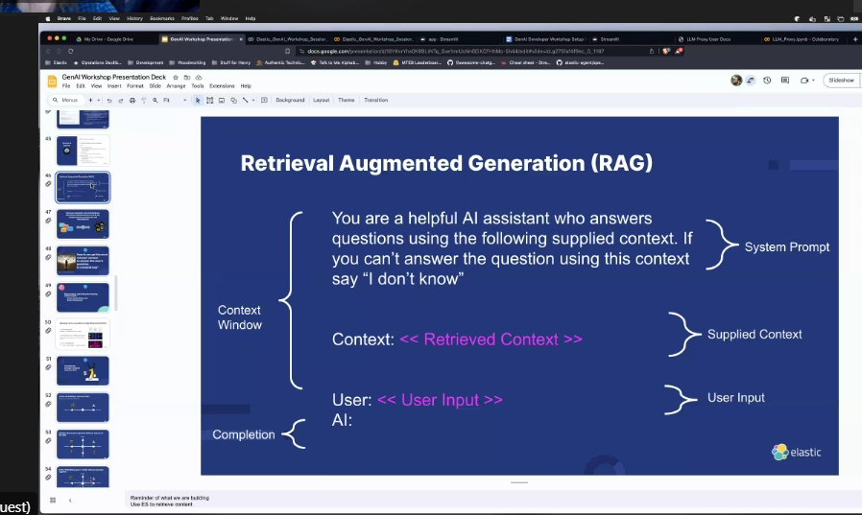



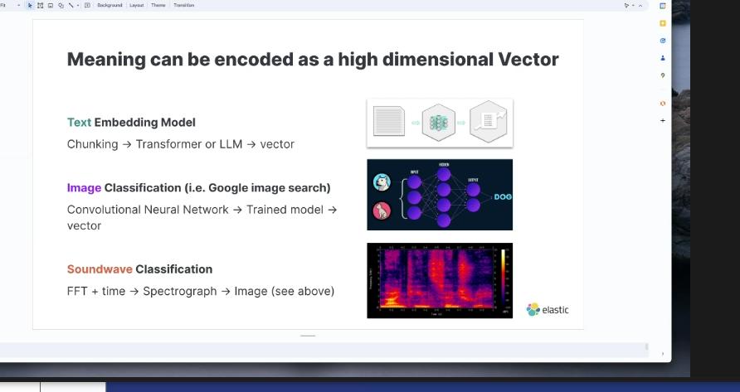

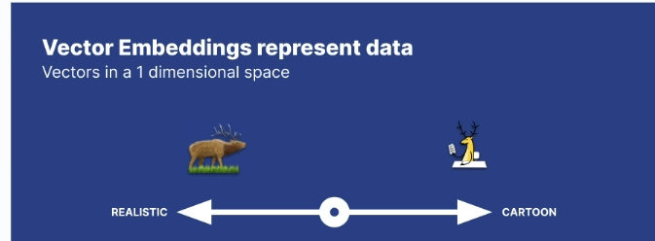

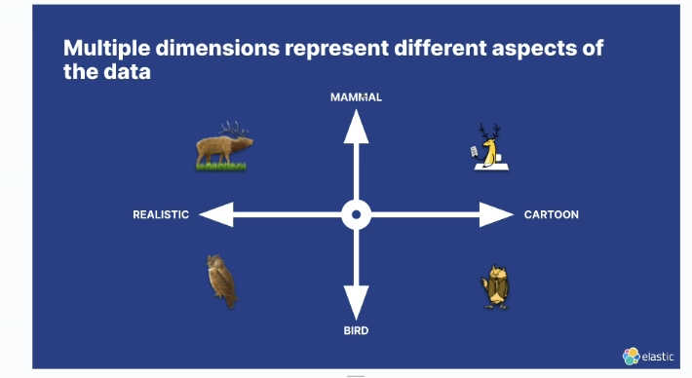

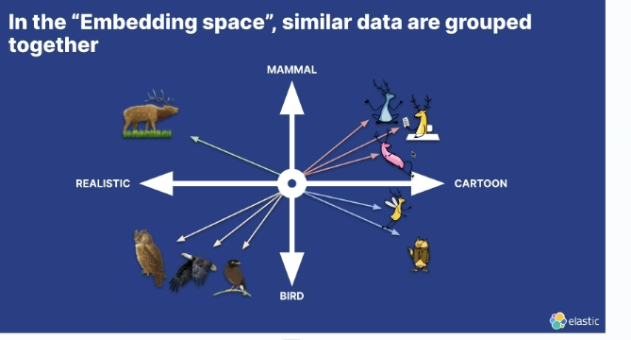

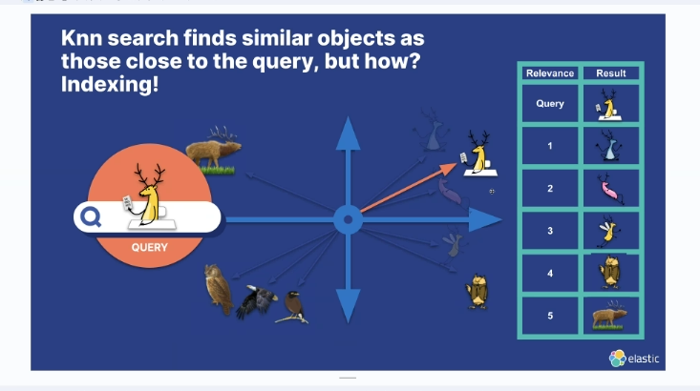

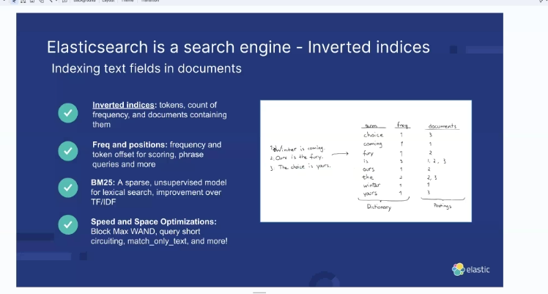

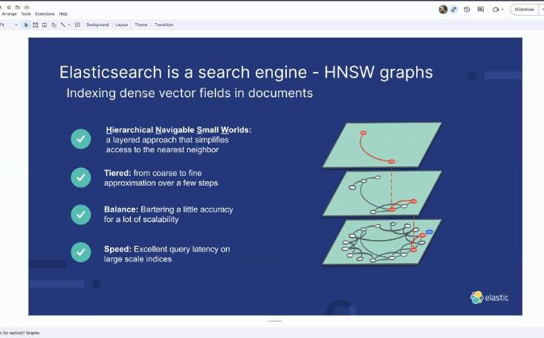

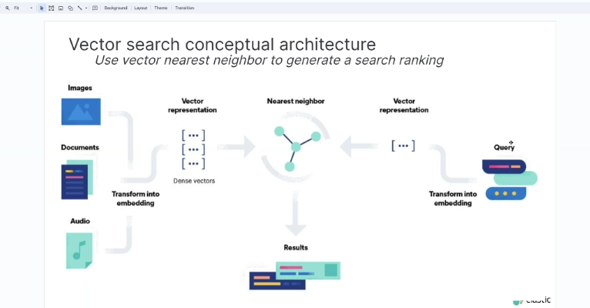

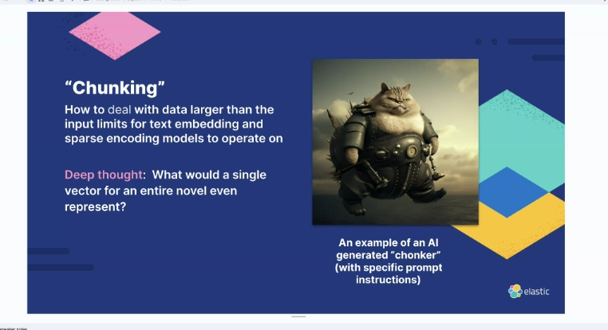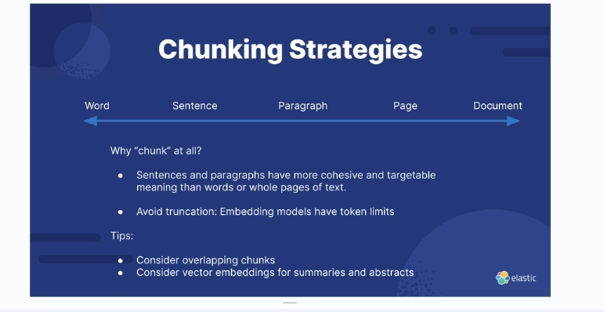

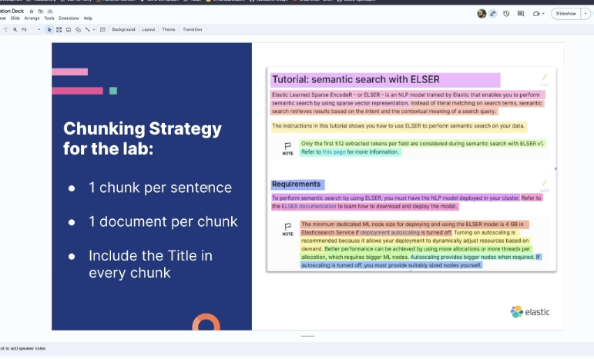

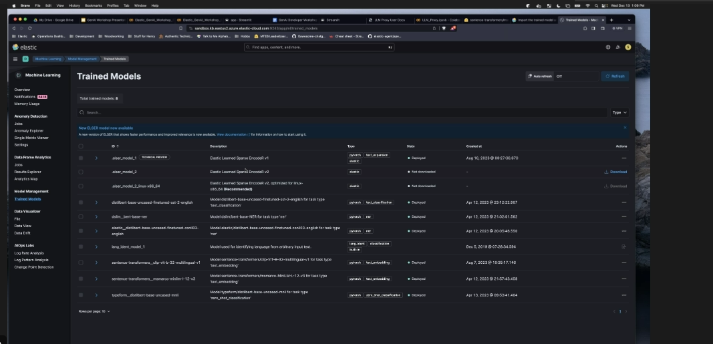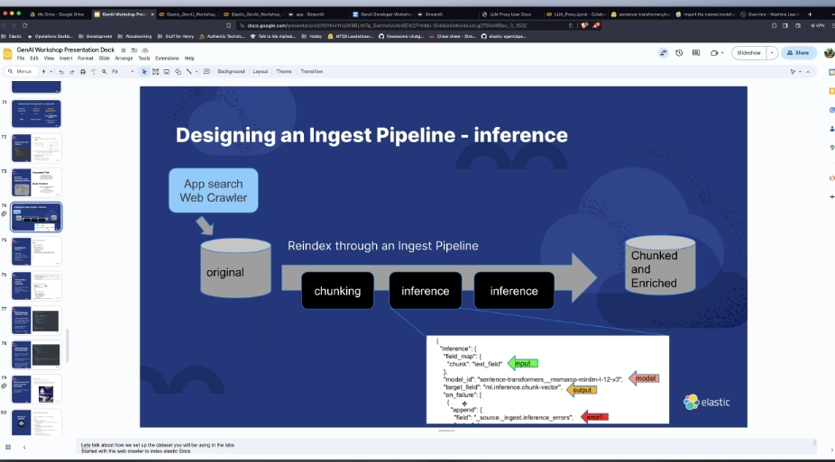

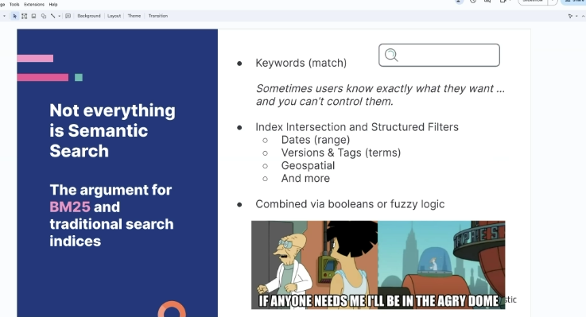

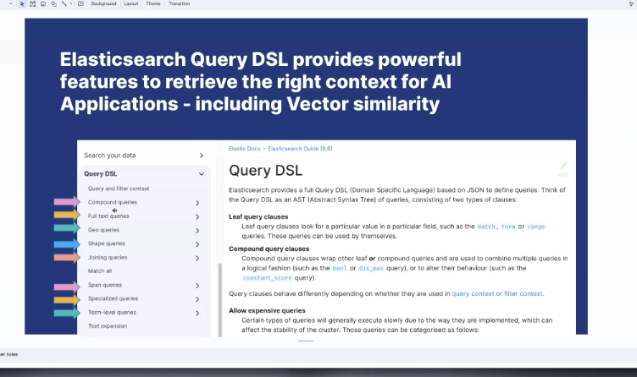



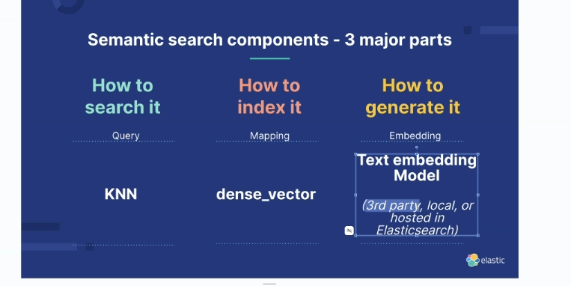

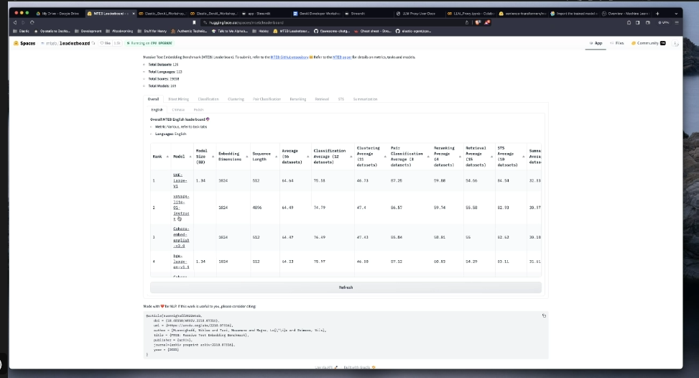

Hugging face

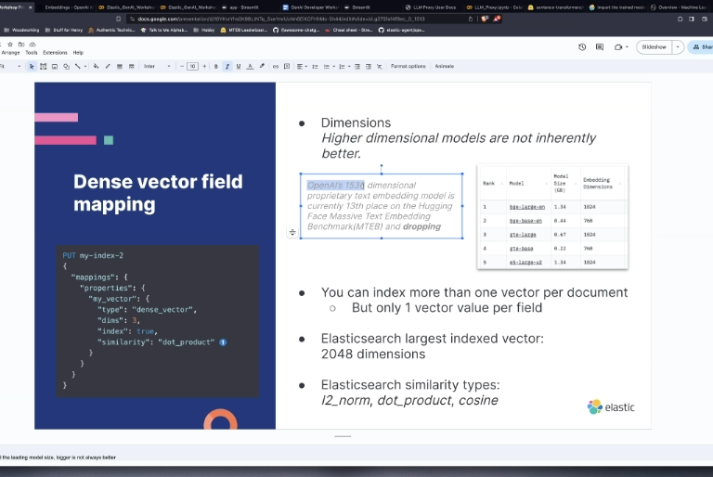

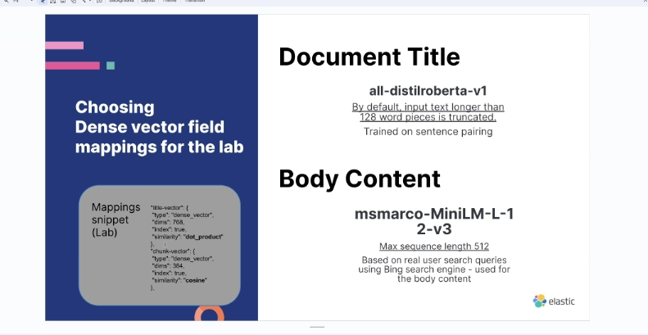

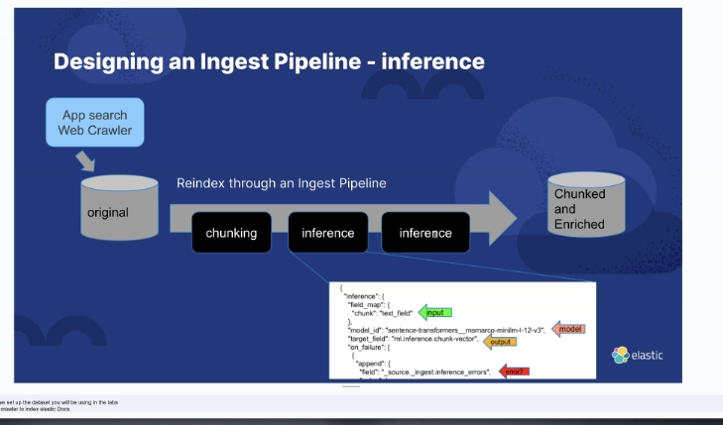

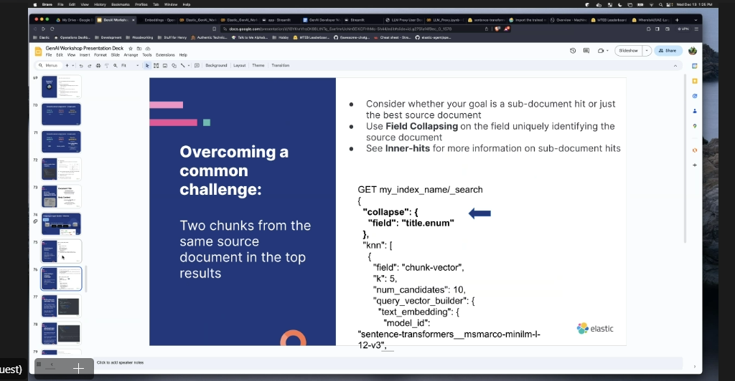 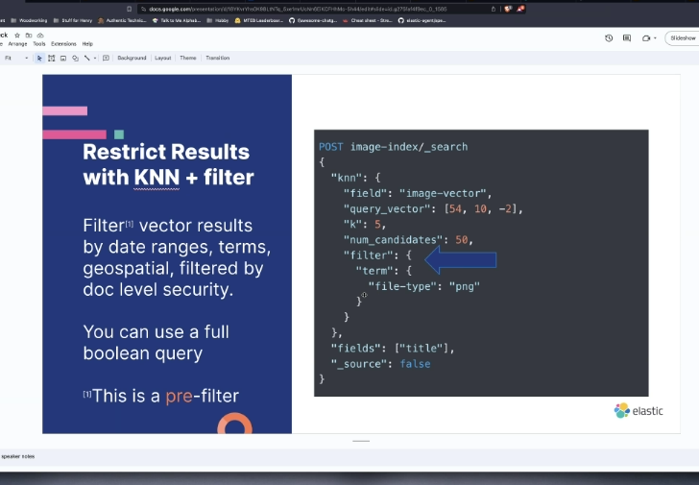

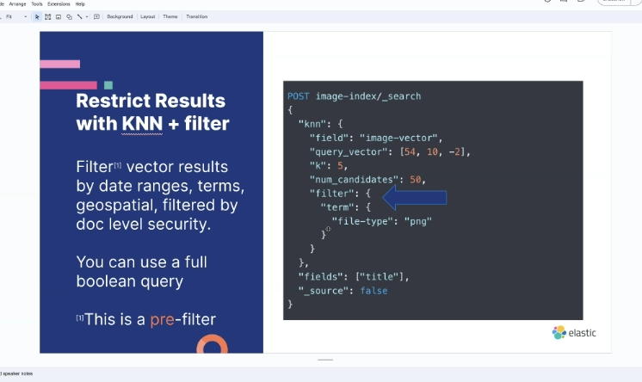

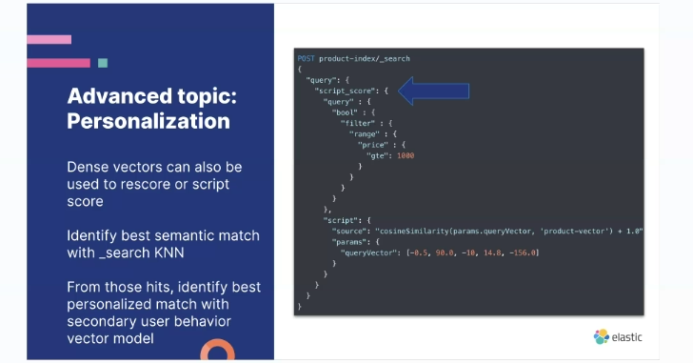

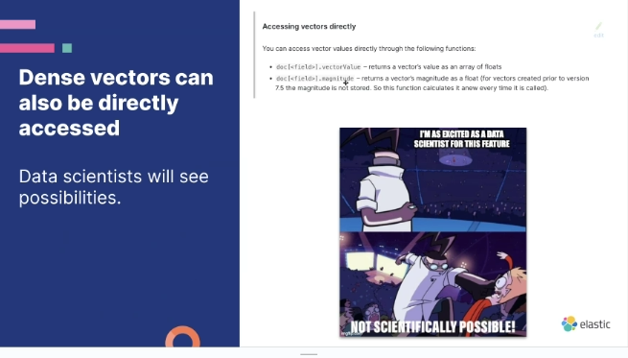

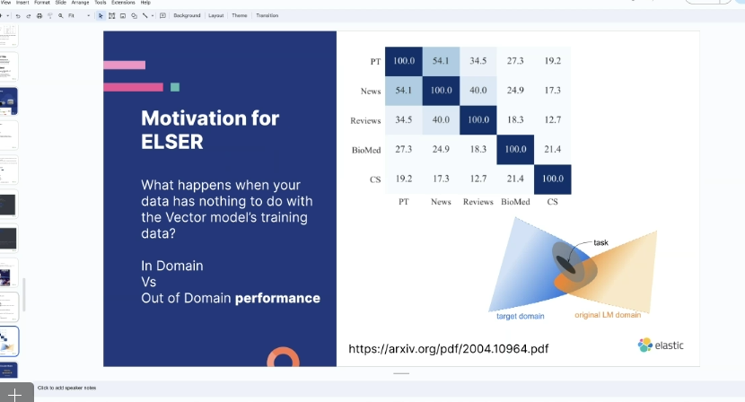

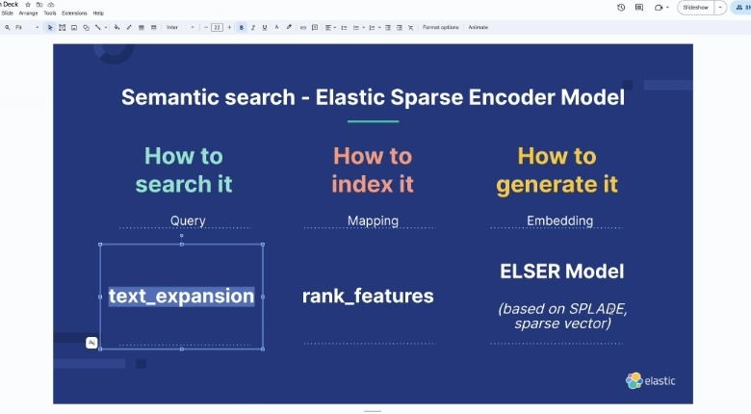

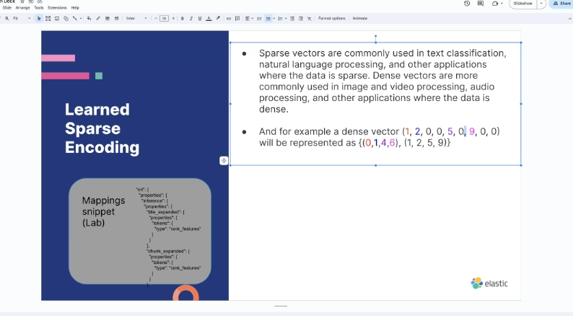

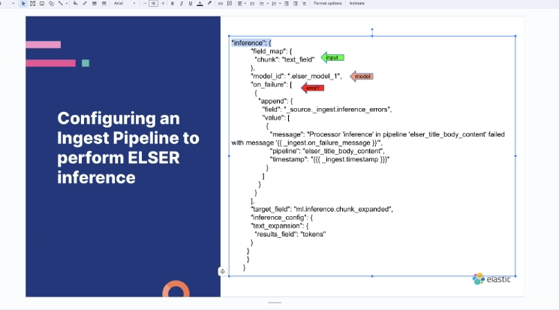

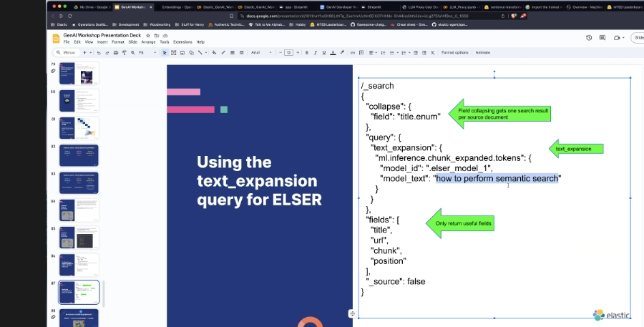

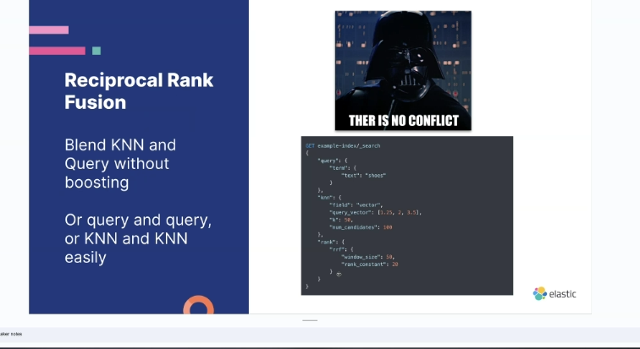

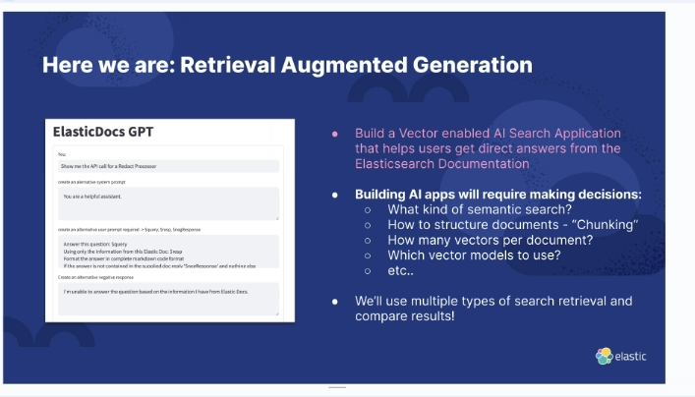

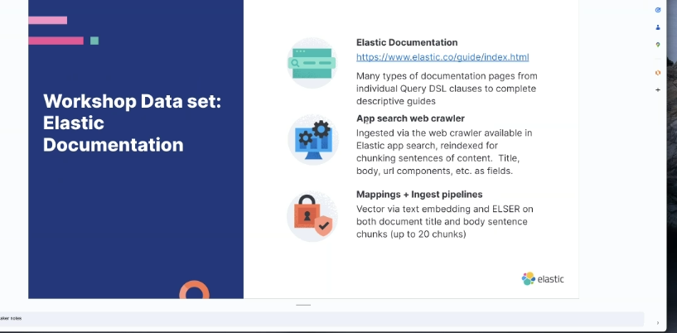

Genereate a code

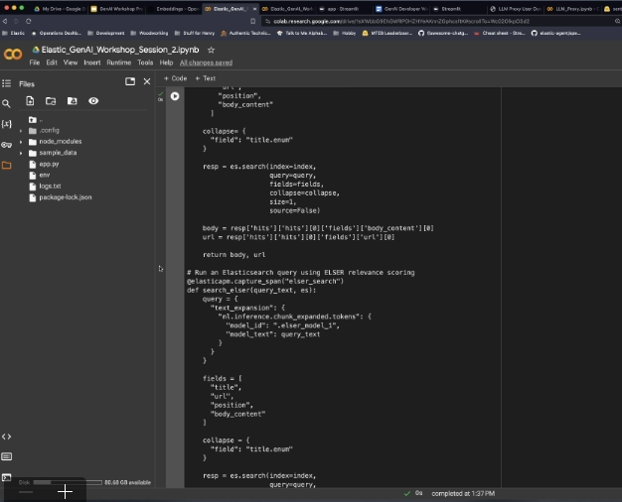

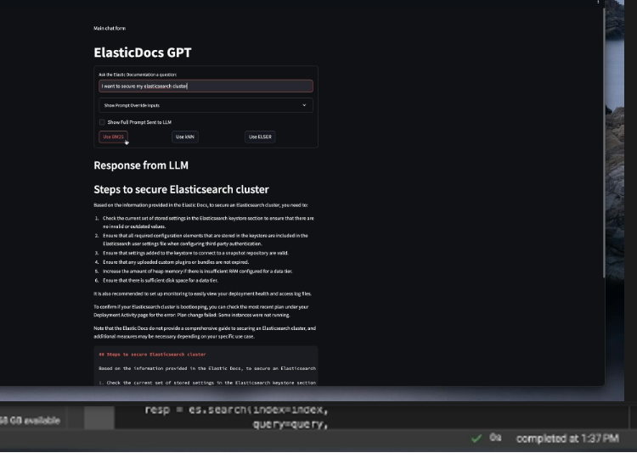

<https://huggingface.co/spaces/mteb/leaderboard>

axonomy is the science of classification, particularly the classification of living organisms into various hierarchical categories based on their characteristics and relationships. The classification system used in biology is called the Linnaean taxonomy, which was developed by Carl Linnaeus in the 18th century. It organizes living organisms into a hierarchical structure that includes several levels of classification, from the broadest to the most specific:

1. Domain: The highest level of classification, which categorizes organisms into three domains: Archaea, Bacteria, and Eukarya.
2. Kingdom: Each domain is further divided into various kingdoms, such as Animalia, Plantae, Fungi, Protista, Archaea, and Bacteria.
3. Phylum: Within each kingdom, organisms are grouped into phyla based on their shared characteristics.
4. Class: Phyla are further divided into classes, which represent a more specific level of classification.
5. Order: Classes are divided into orders, which group together organisms with similar characteristics and features.
6. Family: Orders are further divided into families, which represent a more specific level of classification and include related organisms.
7. Genus: Families are divided into genera, which group together closely related species.
8. Species: The lowest and most specific level of classification, species refers to a group of organisms that can interbreed and produce fertile offspring.  
     
   This hierarchical classification system helps scientists organize and understand the vast diversity of living organisms on Earth.

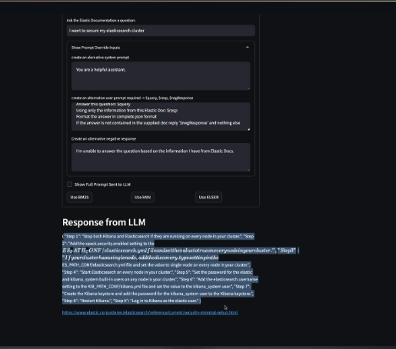

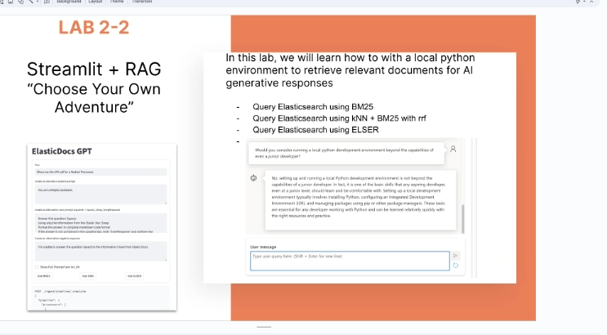

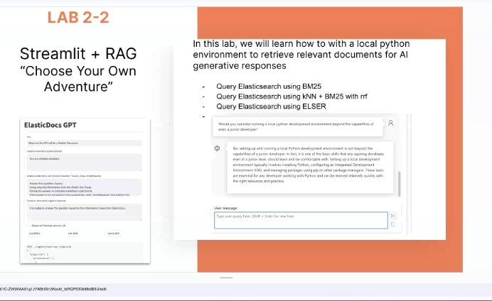

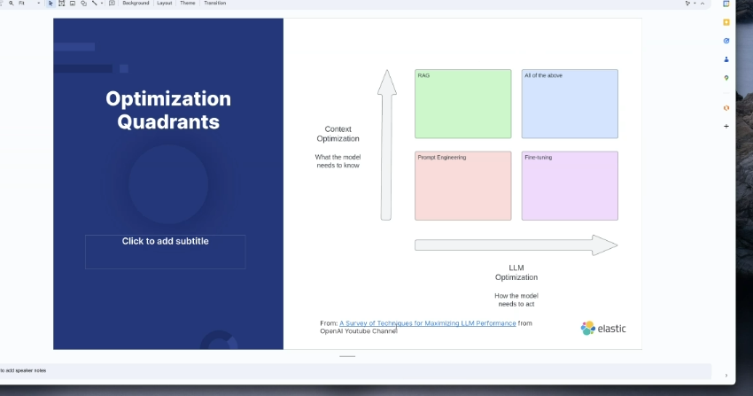

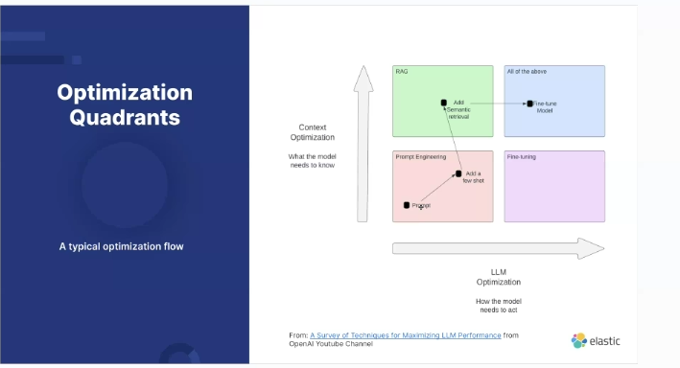

Video

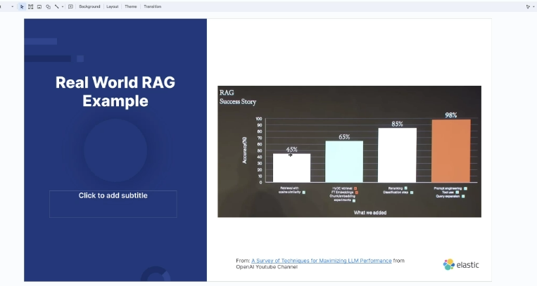

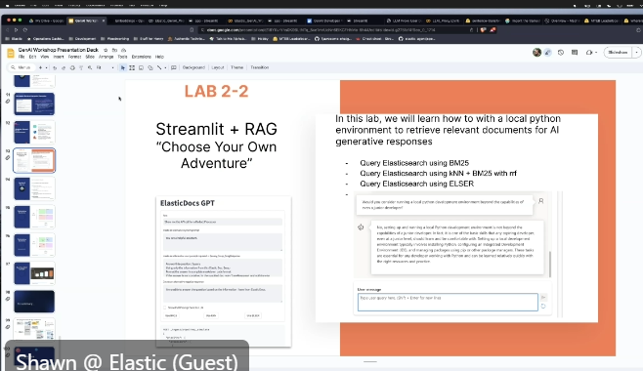

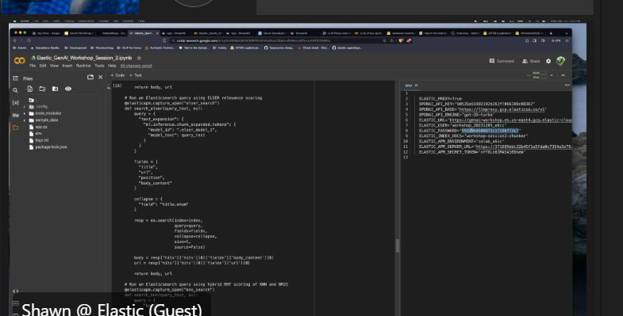

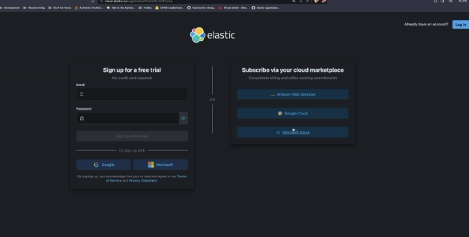

12.07.23

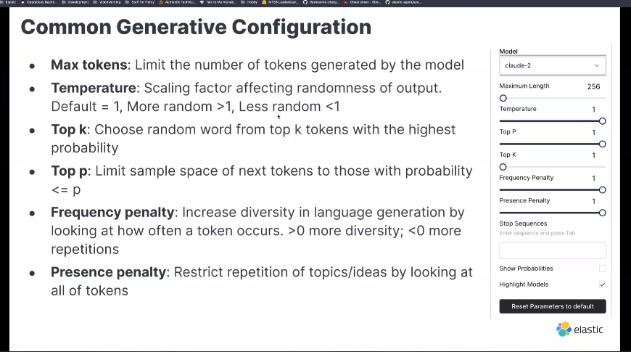

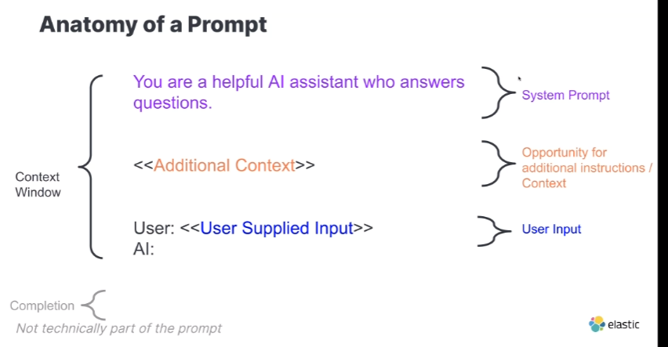

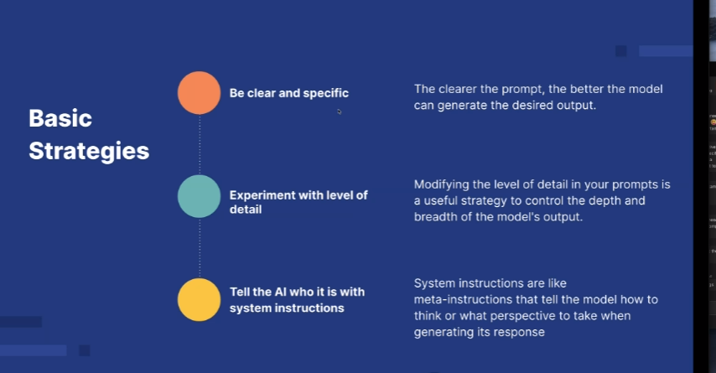

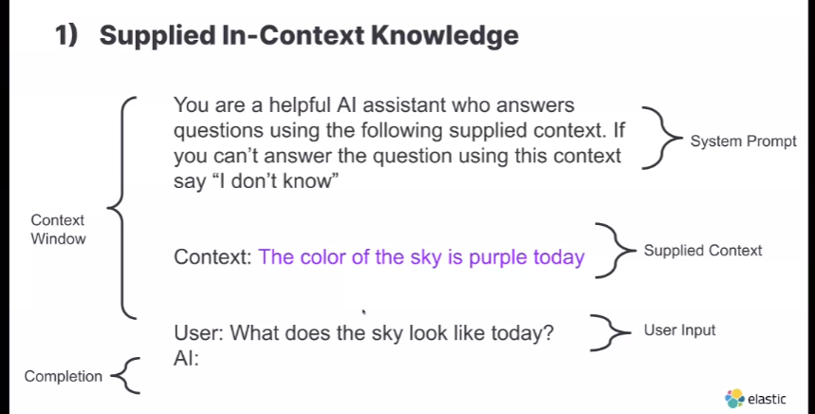

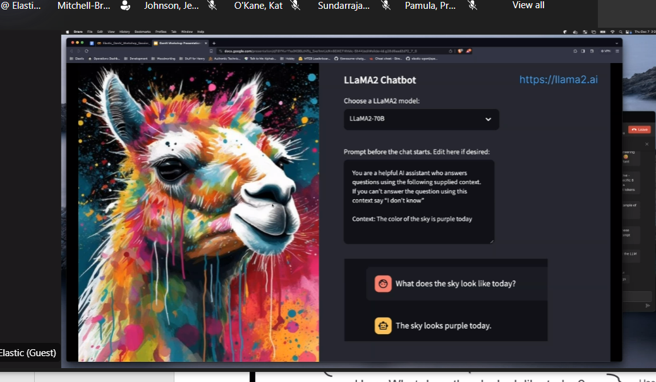

12.06.23

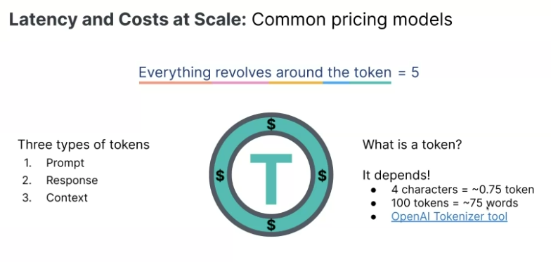

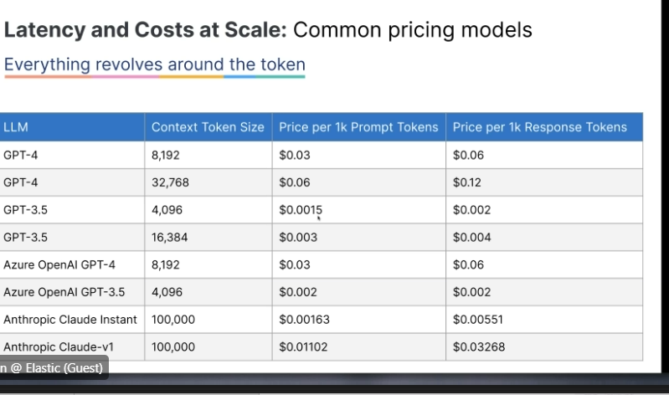

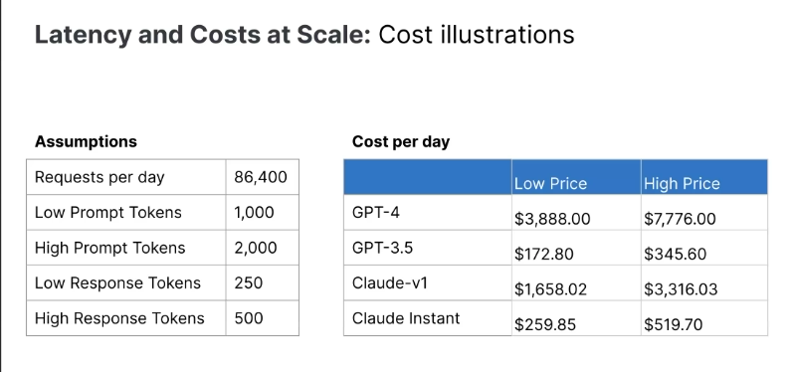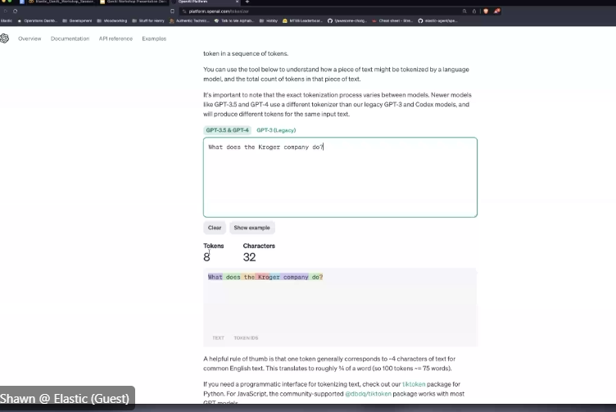

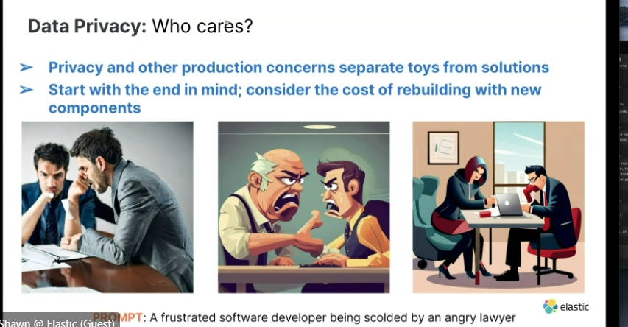

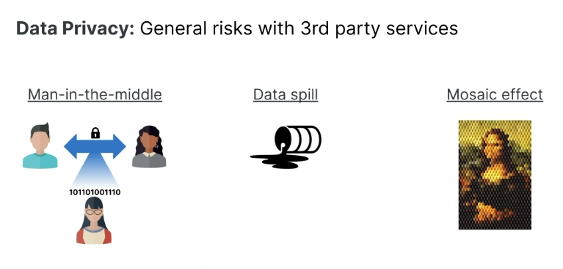

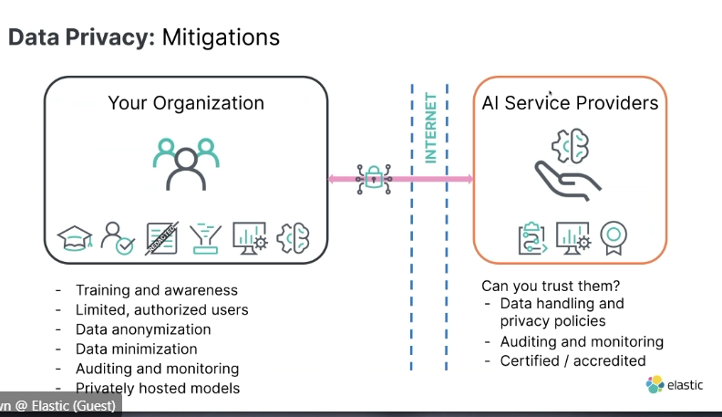

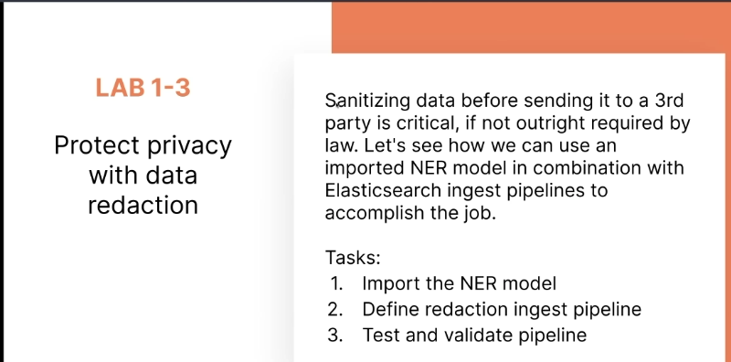

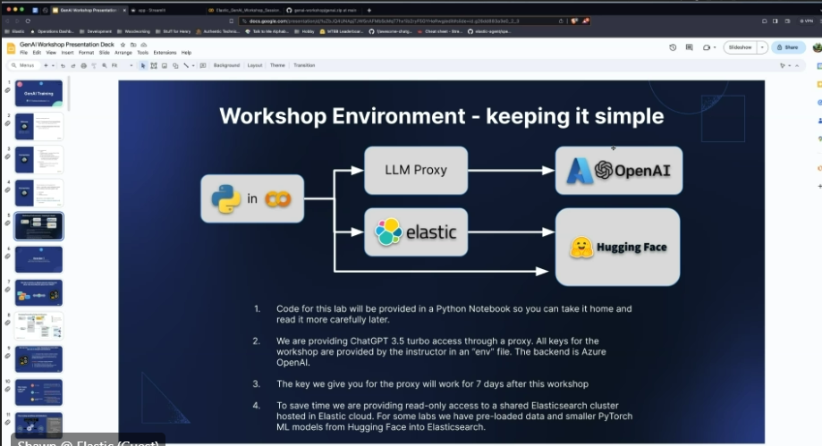

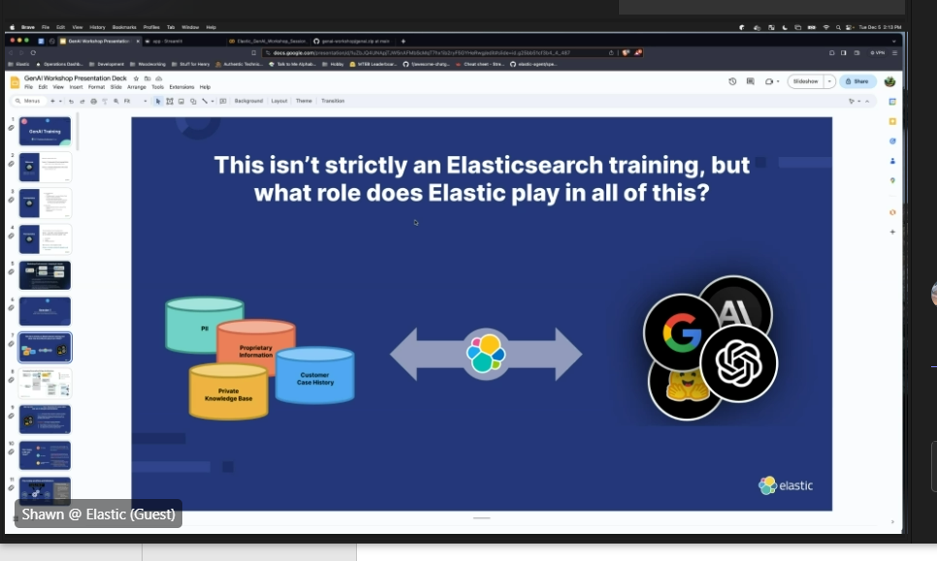

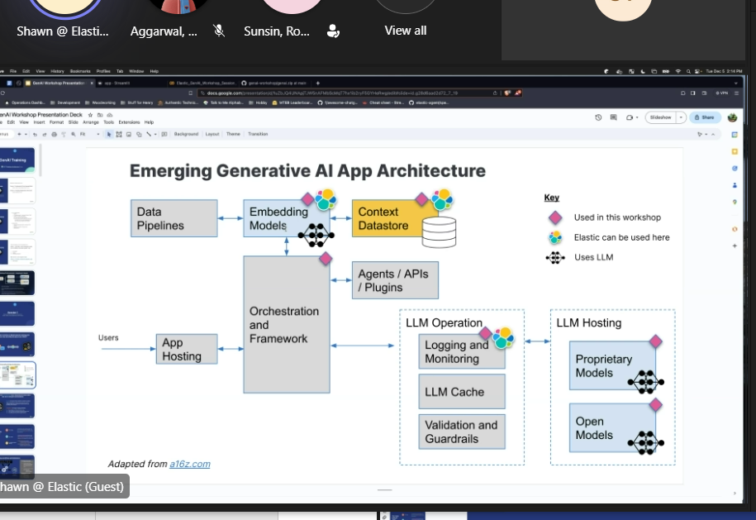

[2:07 PM] O'Kane, Kat

[2:03 PM] Shawn @ Elastic (Guest)

[https://colab.research.google.com](https://colab.research.google.com/)

<https://colab.google.com>

<https://github.com/codingogre/genai-workshop/raw/main/genai.zip>

^ notebook is available here with a sample dataset that is safe to use

Google Colaboratory

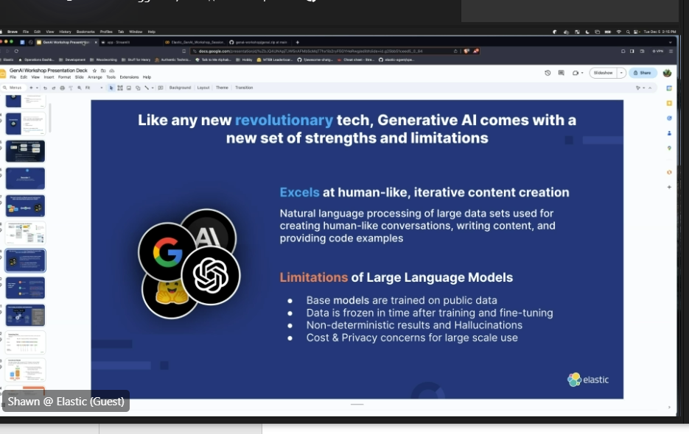

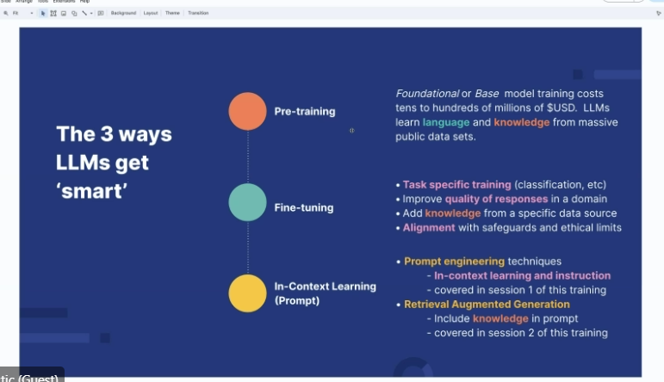

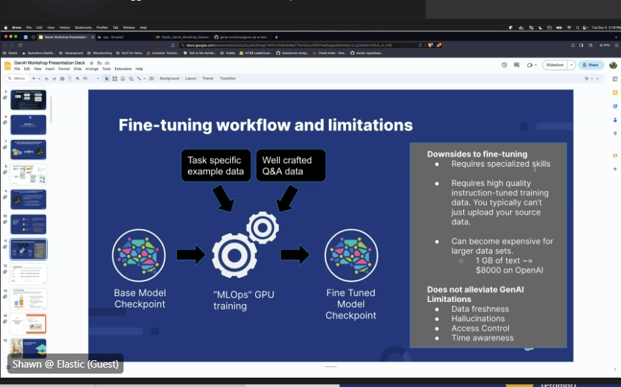

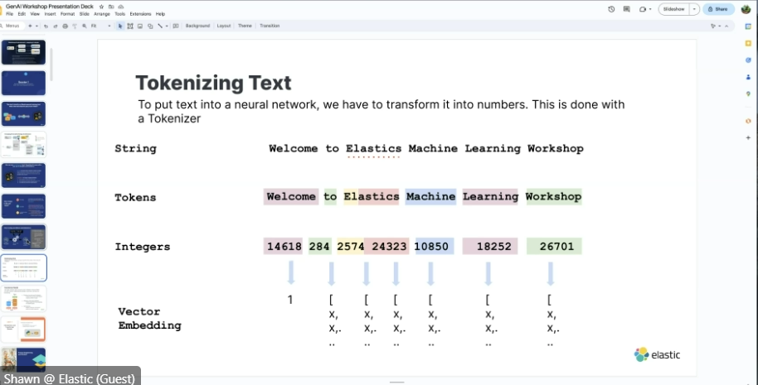

[AI and ML Roles & Job Descriptions | KTD AI and ML Home (kroger.com)](https://confluence.kroger.com/confluence/kam/ai-and-ml-roles-job-descriptions-345556044.html)

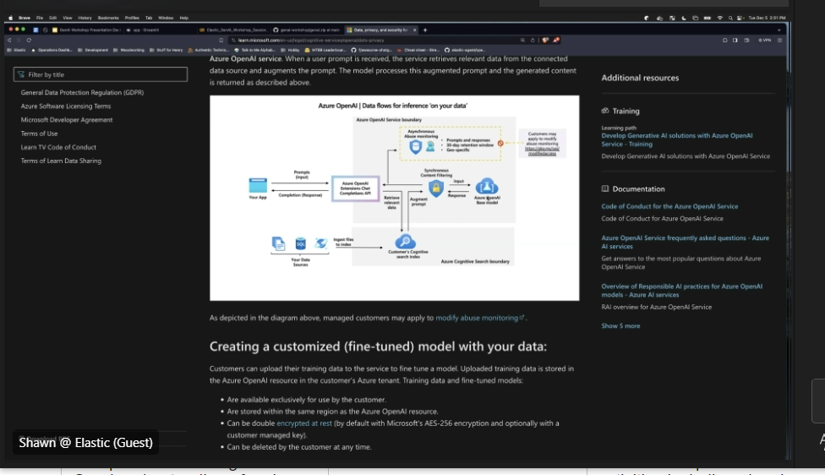

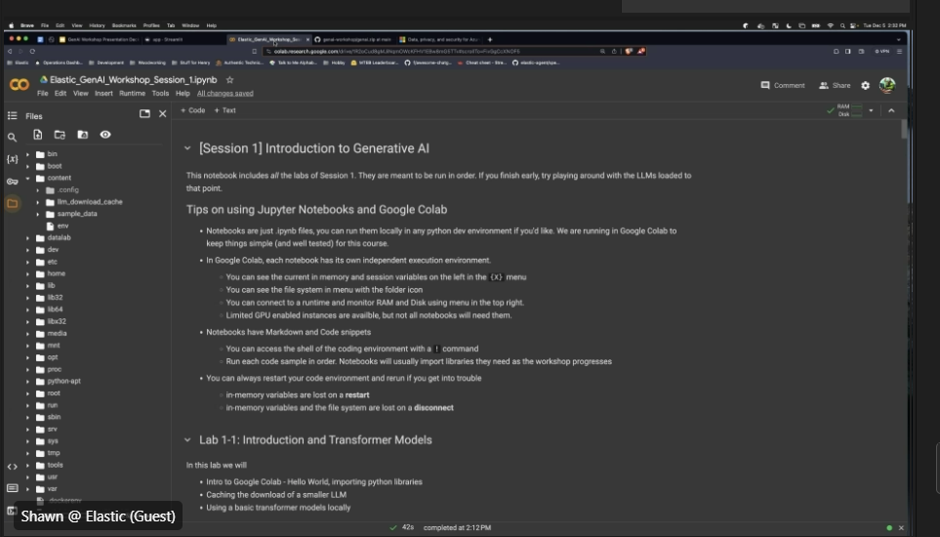

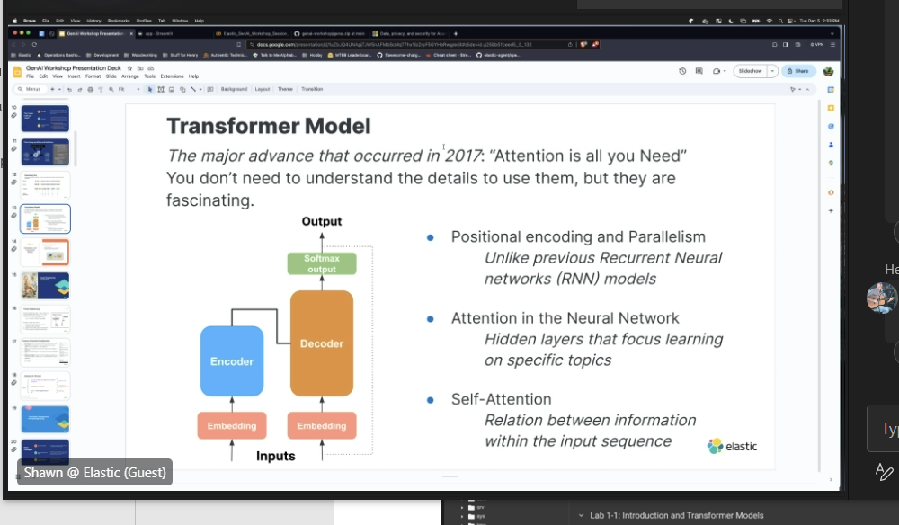

\

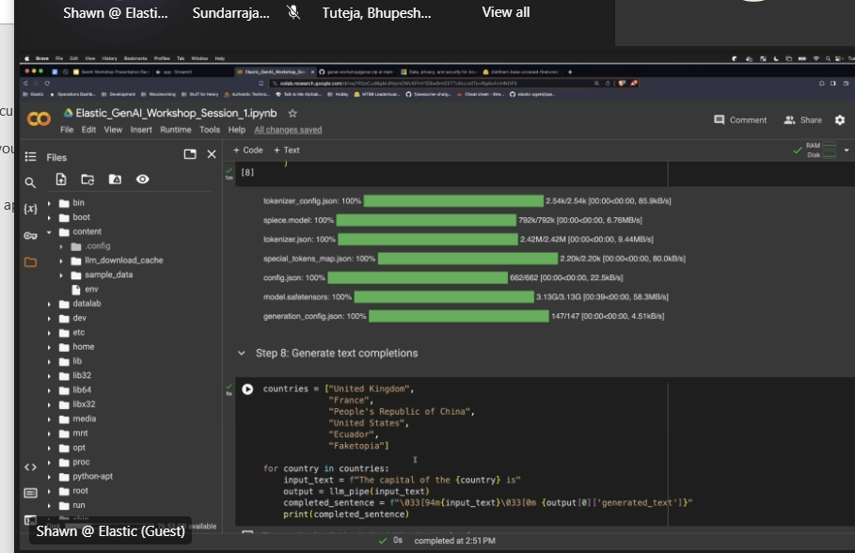

12.7.23

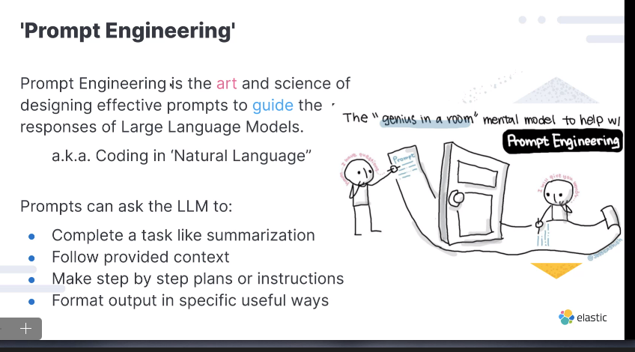

MLPClassifier

The MLPClassifier is a class in the scikit-learn library in Python that implements a multi-layer perceptron (MLP) algorithm for classification tasks. MLP is a type of artificial neural network that consists of multiple layers of interconnected nodes (neurons). It is a feedforward neural network, meaning that information flows in one direction, from the input layer through the hidden layers to the output layer.  
  
The MLPClassifier in scikit-learn allows you to create and train a MLP model for classification problems. It supports various activation functions, optimization algorithms, regularization techniques, and other hyperparameters that can be tuned to improve the model's performance.  
  
To use the MLPClassifier, you need to import it from the sklearn.neural_network module, create an instance of the classifier, specify the desired hyperparameters, and then fit the model to your training data. After training, you can use the model to make predictions on new, unseen data.  
  
Here is an example of how to use MLPClassifier in scikit-learn:

from sklearn.neural_network import MLPClassifier

# Create an instance of the MLPClassifier

clf = MLPClassifier(hidden_layer_sizes=(100, 50), activation='relu', solver='adam', random_state=42)

# Fit the model to the training data

clf.fit(X_train, y_train)

# Make predictions on new data

predictions = clf.predict(X_test)

In this example, we create an MLPClassifier with two hidden layers of 100 and 50 neurons, respectively. We use the rectified linear unit (ReLU) activation function, the Adam optimization algorithm, and set the random state for reproducibility. We then fit the model to the training data and use it to make predictions on the test data.  
  
Note that the specific hyperparameters and their values may vary depending on the problem and data you are working with. It is often necessary to experiment and tune these hyperparameters to achieve the best performance for your specific task.

SMOTE (Synthetic Minority Over-sampling Technique) is a data augmentation technique used to address class imbalance in machine learning datasets. Class imbalance occurs when the number of instances belonging to one class is significantly lower than the number of instances belonging to another class. This can lead to biased models that perform poorly on the minority class.  
  
SMOTE works by creating synthetic samples of the minority class by interpolating between neighboring instances of the same class. Here's how it works:

1. Identify the minority class: Determine which class is the minority class in your dataset.
2. Select a minority instance: Randomly choose an instance from the minority class.
3. Find k nearest neighbors: Find the k nearest neighbors of the selected instance from the minority class. The number of neighbors to consider, k, is a user-defined parameter.
4. Generate synthetic instances: For each selected instance, choose one of its k nearest neighbors randomly. Create a synthetic instance by interpolating between the chosen instance and the selected instance. This is done by taking a random linear combination of the feature values of both instances.
5. Repeat steps 2-4: Repeat steps 2 to 4 until the desired balance between the minority and majority classes is achieved.  
     
   SMOTE helps to balance the class distribution by creating synthetic instances of the minority class, thus increasing its representation in the dataset. This can improve the performance of machine learning models by providing more training examples for the minority class.  
     
   There are various implementations of SMOTE available in different machine learning libraries, such as imbalanced-learn in Python or DMwR in R. These libraries provide easy-to-use functions to apply SMOTE to your datasets.

Bertopic

1. Bertopic is a text clustering algorithm that leverages the power of BERT (Bidirectional Encoder Representations from Transformers) embeddings to perform topic modeling on textual data. It is an extension of the popular topic modeling algorithm called Latent Dirichlet Allocation (LDA).  
     
   Bertopic works by first converting each document in the dataset into its BERT embedding representation. BERT is a pre-trained language model that captures the contextual meaning of words and sentences. These embeddings capture rich semantic information about the text.  
     
   Once the documents are transformed into BERT embeddings, Bertopic applies dimensionality reduction techniques to reduce the high-dimensional embeddings into a lower-dimensional space. It then performs clustering using HDBSCAN (Hierarchical Density-Based Spatial Clustering of Applications with Noise), which is a density-based clustering algorithm.  
     
   The resulting clusters represent different topics within the dataset, where each cluster contains similar documents. Bertopic also provides an option to visualize the clusters using Uniform Manifold Approximation and Projection (UMAP), a dimensionality reduction technique.  
     
   Bertopic has several advantages over traditional topic modeling algorithms like LDA. It can handle large datasets and does not require the number of topics to be specified in advance. Additionally, it captures the contextual meaning of words, resulting in more accurate and interpretable topic representations.  
     
   Bertopic is available as a Python library called "bertopic" and can be easily integrated into your text analysis pipeline. You can find more information, examples, and documentation on how to use Bertopic on the official GitHub repository: <https://github.com/MaartenGr/BERTopic>

product attribute

A product attribute refers to a specific characteristic or feature of a product that helps describe or differentiate it from other products. Product attributes can be both physical and non-physical, and they play a crucial role in marketing and consumer decision-making processes.  
  
Here are a few examples of product attributes:

1. Size: The physical dimensions or measurements of a product, such as length, width, height, or capacity.
2. Color: The specific hue or shade of a product. This attribute is particularly important for products like clothing, home decor, and electronics.
3. Material: The substance or composition from which a product is made. For example, a garment could be made of cotton, polyester, or silk.
4. Weight: The mass or heaviness of a product. This attribute is relevant for items like appliances, luggage, and packaging materials.
5. Durability: The ability of a product to withstand wear, tear, or damage over time. It indicates the product's longevity and quality.
6. Performance: The functional capabilities or features of a product. For instance, the processing speed of a computer or the battery life of a smartphone.
7. Price: The monetary value or cost of a product. Price is a critical attribute that influences consumer purchasing decisions.
8. Brand: The name or reputation associated with a product. Brand attributes include factors like brand recognition, brand loyalty, and brand reputation.
9. Packaging: The design, materials, and functionality of a product's packaging. Packaging attributes can include factors like ease of use, sustainability, and visual appeal.
10. Warranty: The guarantee or promise provided by a manufacturer or seller regarding the quality, performance, or repair of a product within a specified period.  
      
    These are just a few examples of product attributes, and the specific attributes associated with a product can vary depending on the industry, product category, and target market. Identifying and effectively communicating the relevant attributes of a product is essential for marketing, product differentiation, and meeting customer needs and preferences.

Rapidfuzz

RapidFuzz is a Python library that provides efficient string matching and fuzzy string matching functions. It is designed to help with tasks such as string similarity, string matching, and fuzzy string matching in a fast and memory-efficient manner.  
  
The library offers various functions for different string matching needs, including:

1. String similarity calculation: RapidFuzz provides functions to calculate the similarity or distance between two strings using algorithms like Levenshtein distance, Hamming distance, and cosine similarity.
2. Partial string matching: RapidFuzz supports finding partial matches or substrings within larger strings. This can be useful for tasks like autocomplete suggestions or searching for similar substrings.
3. Fuzzy string matching: RapidFuzz includes functions for fuzzy string matching, which allows for more flexible matching by considering variations in spelling, word order, and other factors. It uses algorithms like Levenshtein distance and Jaro-Winkler distance to compute fuzzy matches.
4. Token-based string matching: RapidFuzz provides functions for token-based string matching, which breaks strings into tokens (e.g., words) and calculates similarity or distance based on the tokens. This approach can be helpful for tasks like comparing sentences or documents.  
     
   RapidFuzz is known for its speed and memory efficiency, making it suitable for large-scale string matching tasks. It is compatible with Python 3.x and can be easily installed using pip. The library provides a straightforward API and offers various configuration options to customize the matching behavior based on your specific requirements.  
     
   You can find more information, examples, and documentation on how to use RapidFuzz on the official GitHub repository: <https://github.com/maxbachmann/RapidFuzz>

Applied Logictic regression, multi-layer perceptron Classifier(MLPClassifier) with the rectified linear unit (ReLU) activation function, SMOTE (Synthetic Minority Over-sampling Technique) for Taxonomy classification, and utilized BerTopic for Taxonomy Analysis.

Utilized RapidFuzz, OpenAI/Generative AI (GPT 3.5/GPT 4) to predict/normalize product attributes.

AI/ML Guild Presents: ElasticSearch Workshop – GenAI and Prompting Session 1

Session 1 – Fundamentals of AI and Language Models GenAI, LLMs, Prompt Engineering, Privacy Session 2 – Developing AI Applications with Context Vectors, Retrieval Augmented Generation, Cos

Kroger Technology & Digital

[Saturday 8:19 PM] Friemel, Paul A

It’s just the area of the business we are under.